**Assignment_02**

Camera raw: Adobe Photoshop Camera Raw is Adobe’s RAW image-processing engine. It’s what allows you to convert the RAW image files shot by your camera into widely supported, shareable, usable JPGs. If that’s just a load of jargon to you, let me explain. Even iPhones can now capture both RAW and JPG files.

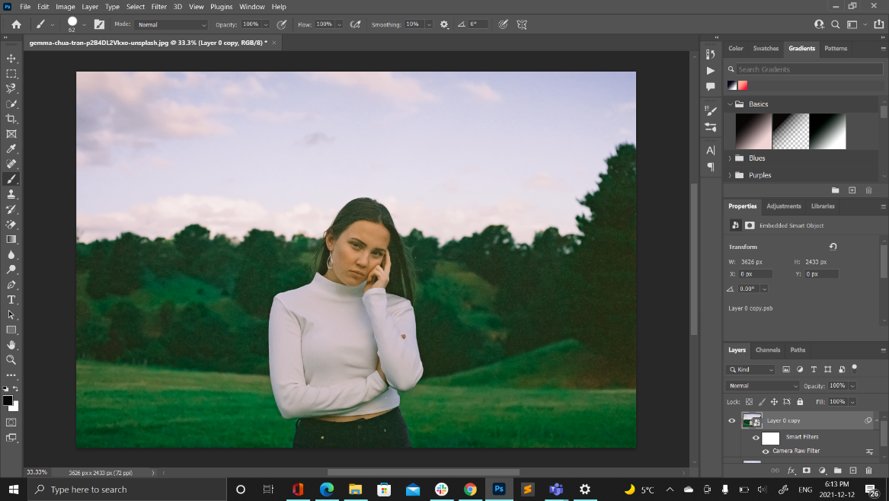

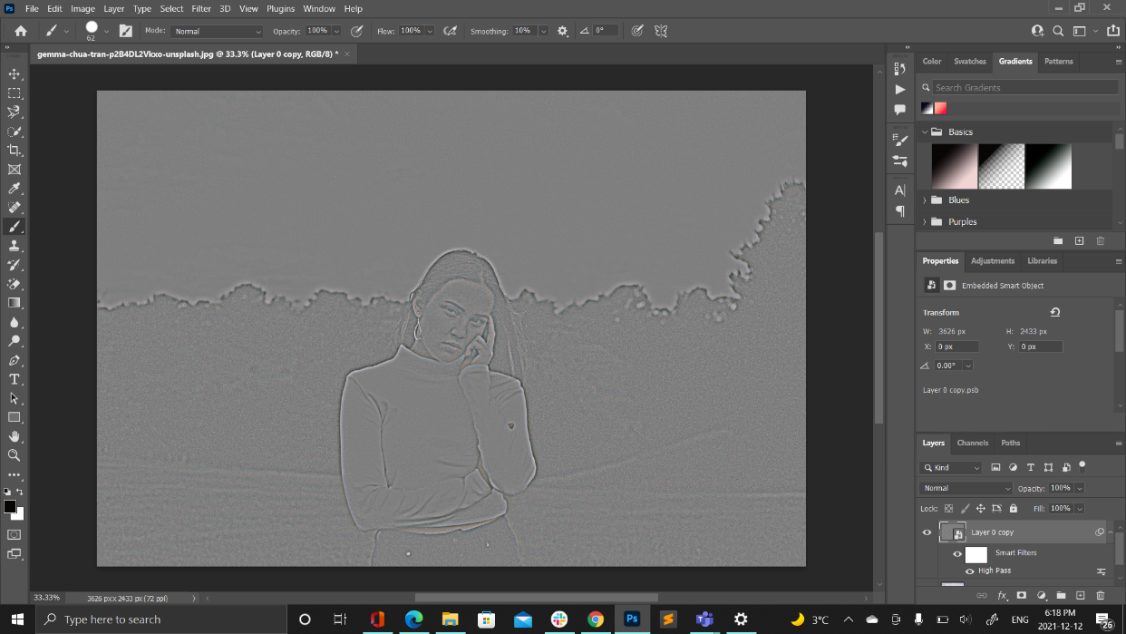High Pass: High Pass is an edge-detection filter. It looks for edges in the image and highlights them. Areas that are not an edge are ignored. Once the edges are highlighted, we can then combine the High Pass results with one of Photoshop's contrast-boosting blend modes to easily increase edge contrast without affecting other parts of the image!

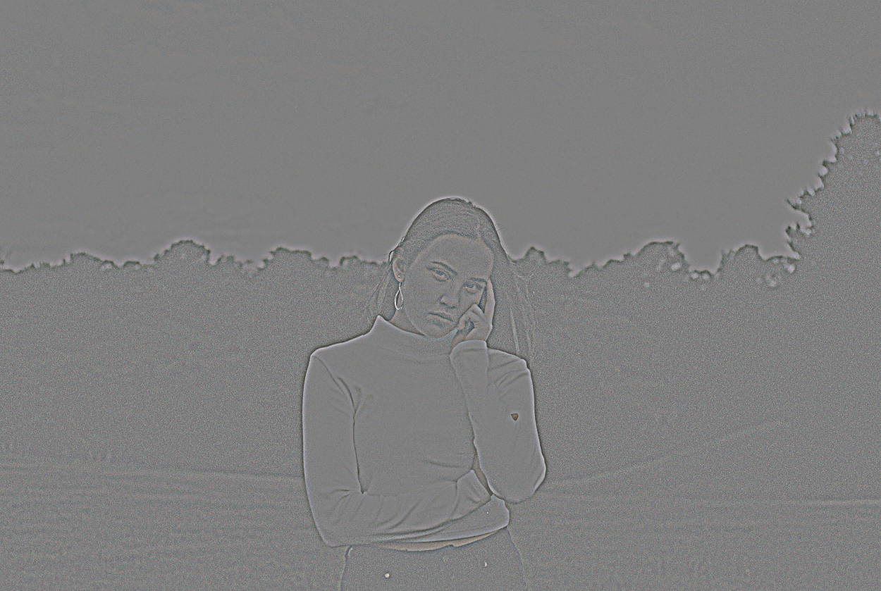

Adjustment Layers: Adjustment Layers are a special kind of Photoshop layer. Rather than having content of their own, they adjust the information on the layers below them. For example, you can use an adjustment layer to increase the brightness or contrast of a photograph without altering the original photo. They’re one of the most important tools to master in Photoshop.

Color Range: Color Range is an effective (and easy) way to make selections when there is a distinctive difference in color between your target selection and the rest of the image.

Lab Color: Lab stands for Lightness, channel a and channel b. Basically, it’s a global color model where you can specify any given color by giving numeric values across these three different channels to edit image colors.